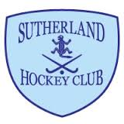

Fee Type | SDHC  Sutherland Hockey Club  2018 Playing Fees  Fee | Sibling Discount  Total SDHC Fee
Senior Men
Full Playing Fee | 515.00 | N/A
Full Playing Fee – Goalie ** | 60.00 | N/A
Full Time Student | 395.00 | N/A
Full Time Student – Goalie ** | 60.00 | N/A
Junior Playing Seniors (U18) * | 270.00 | N/A
Junior Playing Senior (U18) ** Goalie Fee | 60.00 | N/A
Casual Player - Pick-Up-Roster (6 game limit) | 150.00 | N/A
Senior Women
Full Playing Fee | 360.00 | N/A
Full Playing Fee – Goalie ** | 60.00 | N/A
Full Time Student | 280.00 | N/A
Full Time Student Goalie ** | 60.00 | N/A
Junior Playing Seniors (U18) * | 200.00 | N/A
Junior Playing Senior (U18) ** Goalie Fee | 60.00 | N/A
Juniors
U11 | 135.00 | 115.00
U13 | 145.00 | 125.00
U15 | 160.00 | 140.00
U17 | 175.00 | 155.00
Junior Goalie with own gear ** | 30.00 | 10.00
SSHA Junior Girls | 160.00 | 140.00
SSHA Junior Girls but also registered for Mixed | 90.00 | 70.00
Minkey
U7 & U9 minkey | 80.00 | 60.00
Other Memberships:
Masters | 15.00 | N/A
Associate | 15.00 | N/A
Social | 10.00 | N/A

All Fees are exclusive of Hockey NSW & Sydney South Association Fees which are payable online and direct to Hockey NSW (this will include Sydney South Fees). All Sutherland Hockey Club Fees are to be paid direct to Sutherland Hockey Club (direct deposit to SDHC account preferred)
* Junior Playing Senior Fee applies to juniors who have also paid a junior SDHC fee. Juniors under this fee only need to pay Hockey NSW and Sydney South Fee once.
** Goalie discount applies to Goalies with their own gear ONLY
Note: Sibling discount applies to subsequent children playing with SDHC only i.e. 1st Child pays full fee remaining children receive $20 from their appropriate fee.

2018 HNSW SCHEDULE OF FEES:

The following fees are applicable for individual registrations to Hockey NSW and must be paid online via the revolutionise system:

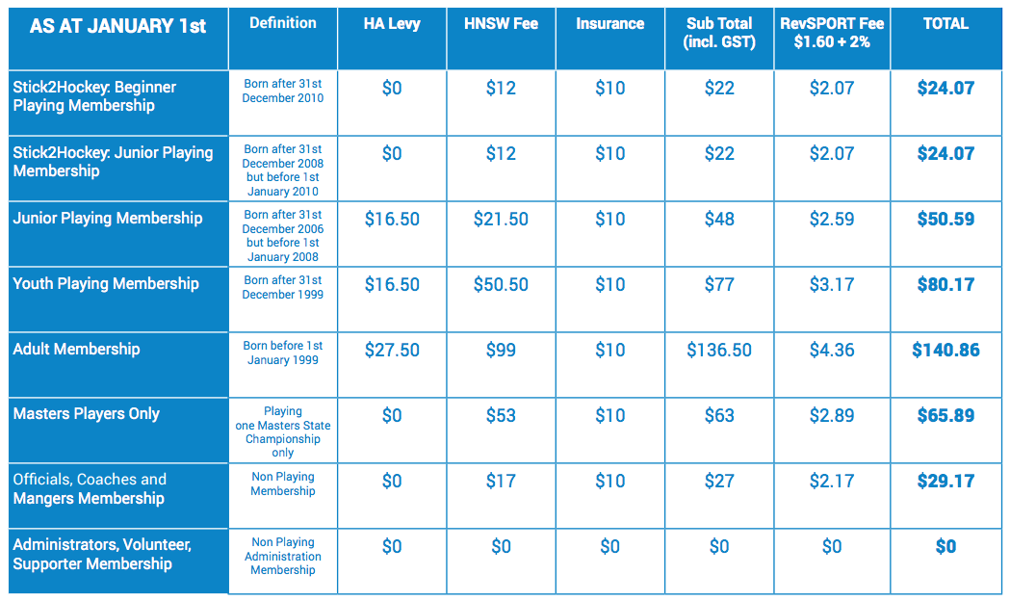

2018 SYDNEY SOUTH ASSOCATION FEES (not confirmed)

Paid along with HNSW fees online via the revolutionise system:

SSHA FEES are likely to be $20 per player except for U9’s who are likely to be $10 per player.

This covers the ASSOCIATION AFFILIATION FEE charged to all associations by HNSW $7.50 + $0.75 (GST) = $8.25 (incl. GST) per registered player (Players primary Association to pay) Fee to be based on 2017 Registrations Invoiced 1st March 2018 – Payment due 31st March 2018

HOCKEY NSW MASTERS ONLY FEE The Masters Only Registration fee has been approved by the Board of Hockey NSW, with the following conditions: • This registration is for the use by players who ONLY compete in one Hockey NSW Masters Field State Championship (usually 4 or 5 games over ONE weekend). • This registration is only available via the Hockey NSW Masters Association in revolutionise. • If a player decides to play in more than one Hockey NSW Masters Field State Championship they will need to upgrade their Subscription to the Adult Membership category.

INSURANCE The 2018 Registration Fee provides insurance coverage from 1st April 2018 - 31st March 2019.

ACTIVE KIDS REBATE

In 2018, the NSW Government will provide a $100 rebate through a voucher system to parents/guardians/carers to contribute to the cost of their children’s participation in sport. The voucher can be redeemed towards payment of registration fees each calendar year.
The program will go live from January 31st, 2018.

Hockey NSW has been working with revolutionise to prepare the online registration system so that the Active Kids Rebate voucher can be used by families for the 2018 winter season. To align with the launch of the Active Kids Rebate program, Hockey NSW will open registrations on 1st February 2018. For further information on the program visit the Office of Sport website:

https://sport.nsw.gov.au/sectordevelopment/activekids

